Tilburg Substation EMC – Project overview and tracker
Project: Advisory services Tilburg Substation EMC
Client: SC&M II V.O.F. | End Client: TenneT
DNV Reference: 00431480-TDT 25-1641
Date :12-12-2025

Meeting list:
- Kickoff – Held on 5 December 2025, 09:30, Attendance (Peet,Juriaan)
- 2nd Feedback meeting – 20 January 2026 Feedback meeting

PROJECT OBJECTIVE
To conduct a Conductive influence evaluation for the new Tilburg substation project, focusing on the impact of short circuits on nearby 3rd party metallic objects (pipelines, data cables, fences, etc.) based on NEN 3654:2023 and EN 50522.
A critical objective is to address the specific challenge regarding high soil resistivity (approx. 500 $Ω⋅m$) which currently results in a calculated station resistance ($R_{a}$) of 0.931 $Ω$ and a potential Ground Potential Rise (GPR) of up to 27.1 kV. The study aims to verify these values and determine if mitigation is required for nearby assets.

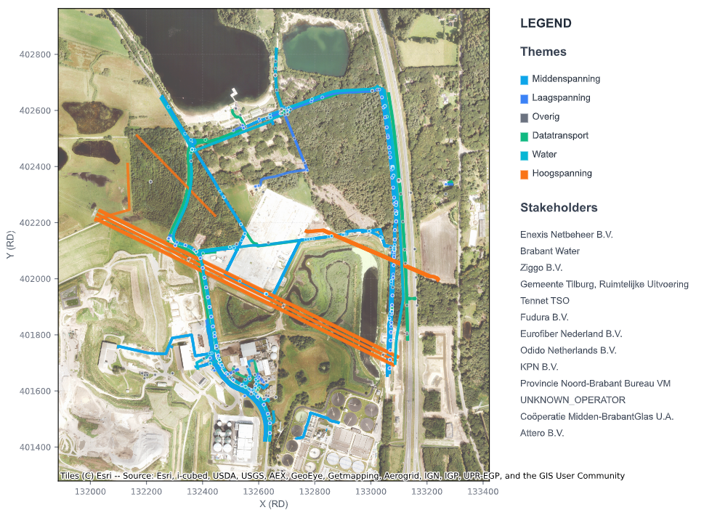
Figure 1: Tilburg substation and surrounding 3rd party assets under study

SCOPE OF WORK & METHODOLOGY
DNV will execute the project in the following phases:

Task 1: Analytical Modeling & Danger Zone Assessment
- Activity: Perform initial analytical modeling to determine the Ground Potential Rise (GPR) and identify the immediate danger zones.
- Output: High-level identification of assets falling within critical influence areas.

Task 2: Data Verification (KLIC vs. Reality)
- Activity: Verification of input data. Specifically, clarifying the status of the pipeline indicated on current KLIC data (which is believed to be removed) versus the actual site conditions.
- Requirement: Client to provide updated "Click data" or as-built drawings to ensure the model does not calculate interference for non-existent assets.

Task 3: Detailed Simulation (CDEGS/XGSLAB)
- Activity: Preparation of a detailed electrode model based on substation design inputs.
- Simulation: Calculation of voltage rise in the soil using a fault current of 29.1 kA.
- Analysis: Plotting results on the terrain against updated asset locations to check compliance with limits.

Task 4: Reporting
- Activity: detailed EMC influence report including calculations and mitigation recommendations (if applicable within the 16-hour scope).

KEY DELIVERABLES
DNV will deliver the following:
- EMC Influence Report: A comprehensive report in English including detailed calculations, methodology, and results plotted against terrain data.

SCHEDULE & TIMELINE
The timeline is based on a 14-week duration as per the proposal.
Milestone | Activity | Baseline Date | Current Forecast | Status | Comments / Changes
T0 | Project Start / Kick-off | 05-12-2025 | 05-12-2025 | CLOSED | Kick-off meeting scheduled.
M1 | Data Collection / Verification | 19-12-2025 | 19-12-2025 | CLOSED | Critical: Confirmation of removed cable data.
M2 | Draft Report Delivery | 12-02-2026 | 12-02-2026 | PLANNED | Based on 14-week schedule minus review time.  It was discussed during the kickoff to aim for end of January  Or beginning of February.
M3 | Client Review Period | 26-02-2026 | 26-02-2026 | PLANNED | 2 weeks allocated for stakeholder feedback.
M4 | Final Delivery | 12-03-2026 | 12-03-2026 | PLANNED | Final version.

MINUTES OF MEETING & ACTION LOG
Project: Tilburg Substation EMC
ID | Category | Description | Owner | Due Date | Latest Status / Comments | Status
A01 | Inputs | Asset Verification: Confirm removal of the pipeline running through the substation terrace. Current KLIC data is outdated. Provide updated drawings/data.  MV cable on site relocated and running now along the fence | Client (SC&M)  Juriaan Koppes | ASAP | [05-12]: Discussed in Kick-off preparation. Essential for accurate modeling. | Closed

DECISIONS & AGREEMENTS
ID | Category | Decision / Agreement | Date Agreed
D01 | Team | DNV Project Manager: Peet Schutte. Engineers: Ivan Grobelaar, Asim Al sofi. | 05-12-2025
D02 | Method | Modeling Approach: The team will first model analytically to check the GPR danger zone before proceeding to detailed CDEGS simulations. | 05-12-2025

RISK REGISTER (Watchlist)
ID | Risk Description | Potential Impact | Mitigation Strategy | Status
R01 | High Soil Resistivity | Deep soil layer resistivity (~500 $Ω⋅m$) may cause Station Resistance ($R_{a}$) to exceed the 0.1 $Ω$target (currently calc. 0.931 $Ω$), leading to high GPR (27.1 kV). | DNV to perform detailed CDEGS modeling to verify conservatism of current assumptions. Highlight specific mitigation needs early. | Active
R02 | Input Data Accuracy | Modeling based on outdated KLIC data (e.g., phantom pipeline) will result in false positives for interference. | Client to verify "Click data" and confirm removal of assets before final simulation runs. | Active

